Novel design of high-resolution parallax-free Compton
enhanced PET scanner DEDICATED TO BRAIN RESEARCH
A. Braem, E. Chesi, C. Joram, S. Mathot, J. Séguinot, P. Weilhammer
CERN, EP Division, CH-1211 Geneva, Switzerland
F. Garibaldi
Istituto Superiore di Sanita, Rome, Italy
E. Nappi
University of Bari, Italy
M. CHAMIZO Llatas
University of Geneva, Switzerland
F. SCHOENAHL, H. Zaidi
Geneva University Hospital, Division of Nuclear Medicine, CH-1211 Geneva, Switzerland
E-mail: habib.zaidi@hcuge.ch

Advances in quantification of brain function (blood flow, metabolism and receptor characteristics) with Positron Emission Tomography (PET), especially for small structures, rely on two improvements: (i) hardware improvements to enhance spatial resolution and sensitivity, and addition of components to correct for physical degrading factors; and (ii) software improvements to attain better image quality and achieve more accurate quantification of relevant parameters. Significant progress has been made by different scanner manufacturers and research groups in the design of high-resolution 3D PET units with the capacity to acquire more accurate depth-of-interaction (DOI) information. However, emerging clinical and research applications of brain imaging demand even greater levels of accuracy and precision and therefore impose more constraints on both aspects, especially with respect to the intrinsic performance of the PET tomograph. Current PET scanners employ bloc detectors consisting of several stacked rings of inorganic scintillating crystals, radially oriented and readout on the backside by standard photomultiplier tubes (PMTs) or multi-anode PMTs. The DOI of the detected photon in the scintillator crystal is not measurable in such a configuration and gives rise to intrinsic parallax errors, hence resolution degradation depending on the emission point in the transaxial plane. This inherent limitation is coped with by keeping the radial length of the crystal small, which strongly compromises the detection efficiency.

A novel concept for a PET detector module is proposed, which provides full 3D gamma reconstruction with high resolution over the total detector volume, free of parallax errors. The key components are a matrix of long scintillator crystals and Hybrid Photon Detectors (HPD) with matched segmentation and integrated readout electronics. They read out the two ends of the scintillator package (Fig. 1). Both excellent spatial (x,y,z) and energy resolution is obtained. The concept allows to enhance the detection efficiency by reconstructing a significant fraction of events which underwent Compton scattering in the crystals. The concept will first be demonstrated with YAP:Ce but can also be applied to other scintillators (e.g. LSO, LuAP, LaBr₃, …). A promising application of the proposed camera module, which is currently under study is a high resolution brain PET with an axial field of view of 10-15 cm dedicated to brain research (Fig. 2). Other applications like PE mammography (PEM) and combination with other modalities are also under investigation.

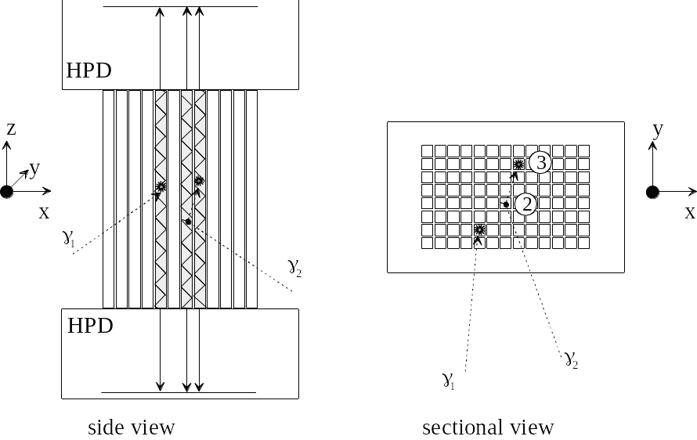 | 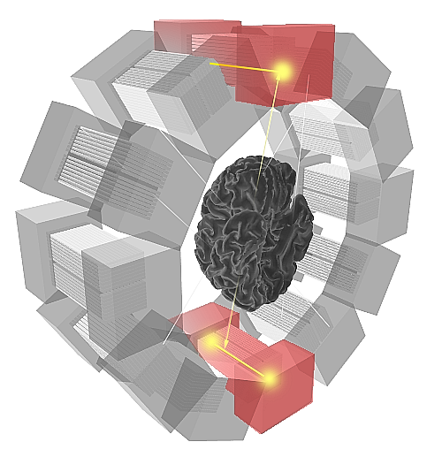
Fig. 1. Principle of 3D camera module. | Fig 2. Illustration of a brain PET scanner based on 12 camera modules.

TOPICS: Imaging Techniques, Biomedical Engineering, Medical/Biological Physics, Radiation Physics.
KEYWORDS: Positron emission tomography, brain imaging, hybrid photon detectors, Compton enhancement.
PREFERENCE: Oral

